**Building work**

1. A building worker is a laborer, bricklayer, who works in the construction industry. He can help you to solve any problems about the building, such as chinks in the wall. In addition, the building worker will also provide some suggestions about the building designer, such as indoor and outdoor environment design and building decoration design.

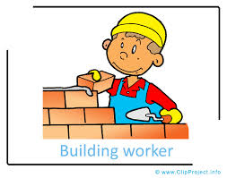

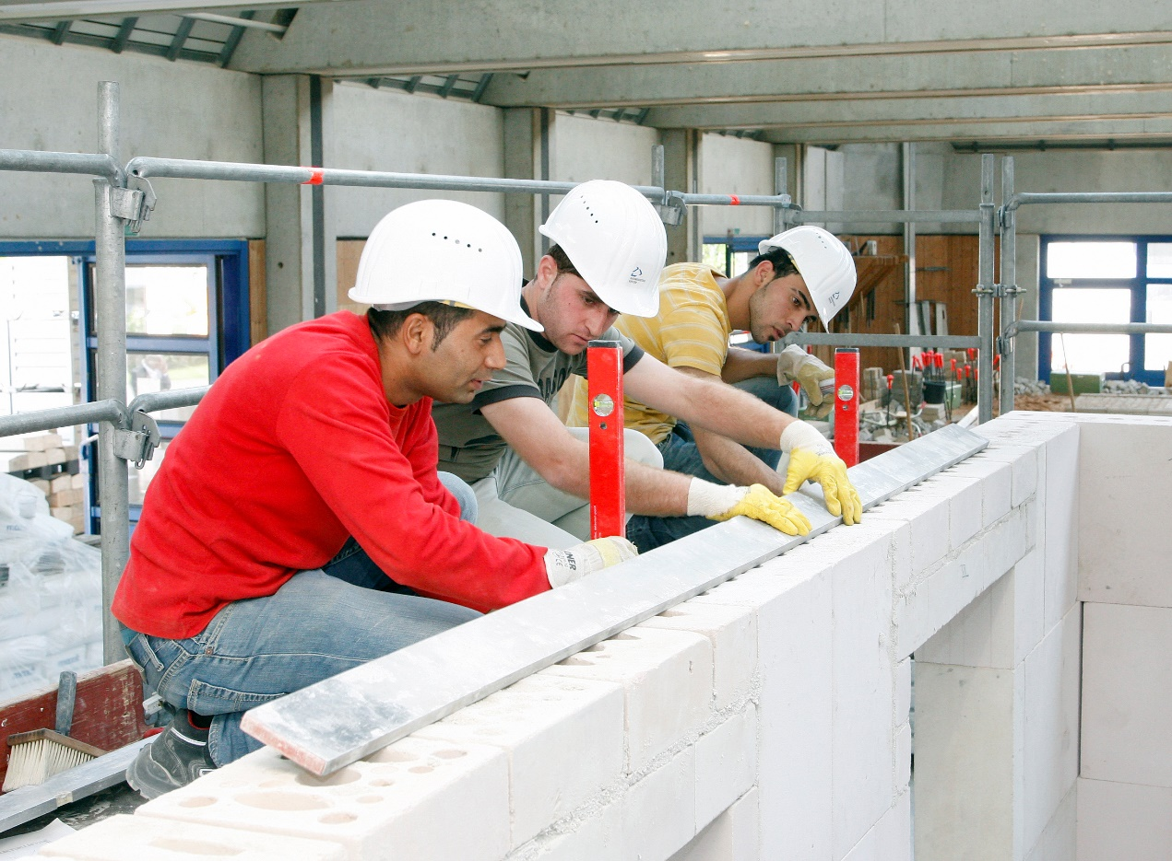

**Air condition**

We provide a service that the service provider can help you to maintenance air condition. If you find your air condition have some problems, we will contact the Special maintenance personnel to help you solve these problems.



